Craft Your Value Proposition - Template

Now that you understand the structure, steps, dos and don'ts of crafting a value proposition, let's review the steps and refine our value proposition.

We will do this through **3 steps:**

|  |  |  |
| --- | --- | --- |

Before you begin this process, remember to first **define your target audience**. If you are having trouble defining your target audience, consider using an interactive workshop format. Using the template below can be helpful to identify and prioritize the characteristics of the target audience in an interactive workshop format. To do this, gather your team and ask them the following questions (this can be done in person or virtually using a platform like Figma or Miro):

* **Which characteristics are relevant to consider when defining an ideal user?** *Use this information to define the section headers.*
* **What does the ideal user look like across these characteristics?***Use stickers to have everyone note what they think the organization should be looking for under each characteristic.*
* **Which characteristics are the most important to consider?** *Use the dot-voting to determine which characteristics are valued most by allowing your team to rank the characteristics.*

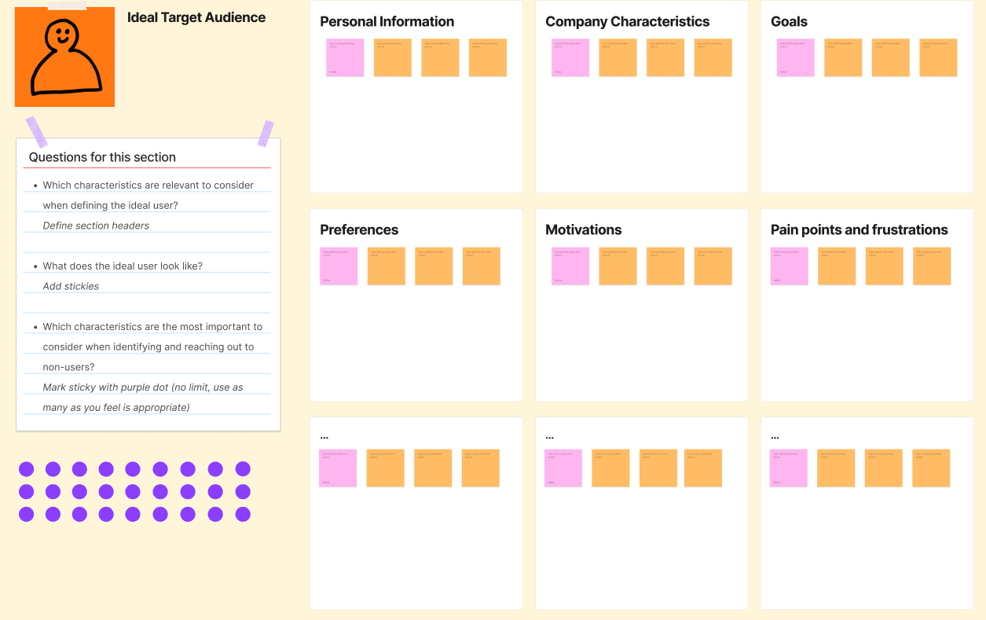

Re-organize and cluster responses to identify common themes. Prioritize which insights are most important to consider and use the results from the workshop to create a clear profile of your target audience.

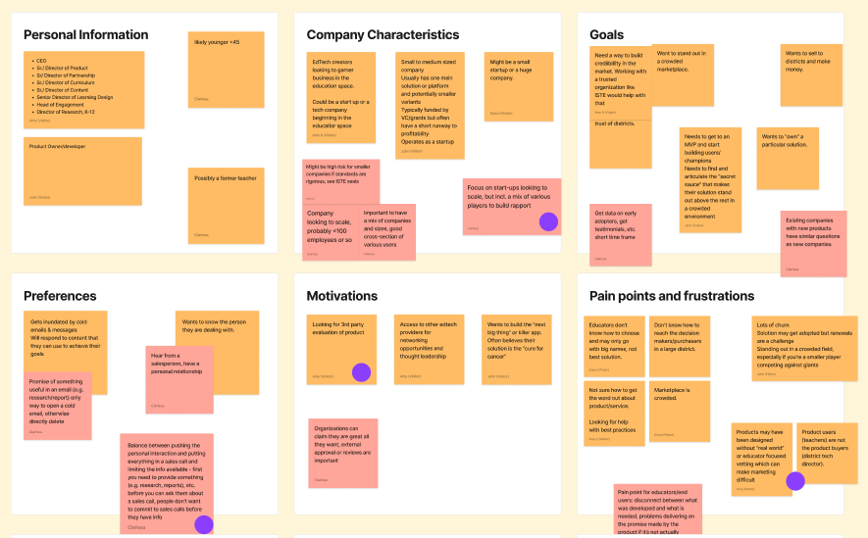

**1. Define the benefits of your services**

Recall the types of evidence (or other products and services) you offer. See if you have described benefits for each offering for district buyers.

You can use the table below to revisit your previously identified **target audience and their needs.**

| **Your Organization:** | |
| --- | --- |
| **Target users:** | **User needs:** |

Revise and refine your previous response with these **guide questions** in mind:

* Why do district buyers need your evidence?
* What value does it add that they cannot get from anywhere else?
* Why do the benefits you described matter to users?

Then, use the space below to answer the question: **What products/services do I offer?**

|  |
| --- |

Lastly, use the space below to answer the question: **How does this benefit my users?**

|  |
| --- |

**2. Link Benefits to Your Users’ Main Challenges**

Put yourself in the shoes of a district buyer and think through the main problems and obstacles they are facing in their decision-making process. This should be informed by previous research on understanding the users including surveys, interviews and focus groups. Think through the key challenges of district buyers and match your offering to these challenges.

You can use the table below to revisit your previously identified **target audience, their needs, and the product/services you offer.**

| **Your Organization:** | |
| --- | --- |
| **Target users:** | **User needs:** |
| **Product/Service I offer:** | |

Revise and refine your previous response with these **guide questions** in mind:

* What problem are you solving that district buyers face?
* Why would district buyers turn to your evidence in the first place?
* What kind of answers are they looking for from you?

If there are any challenges to which you cannot match a solution, or if you offer any services that do not solve an important challenge, this can serve as a basis for thinking through your offering.

Then, use the space below to answer the question: **What are my user’s frustrations or pain points?**

|  |
| --- |

Lastly, use the space below to answer the question: **How does my Product/Service Answer these Frustrations?**

|  |
| --- |

**3. Find Your Differentiator**

Think about what makes your organization unique.

You can use the table below to revisit your previously identified **target audience, their needs, and the product/services you offer.**

| **Your Organization:** | |
| --- | --- |
| **Target users:** | **User needs:** |
| **Product/Service I offer:** | |

Revise and refine your previous response with these **guide questions** in mind:

* What can you offer that no other evidence creator does?
* Why should district buyers engage with your evidence in particular?

Then, use the space below to answer the question: **What makes my product/service unique?**

|  |
| --- |

Lastly, use the space below to answer the question: **Why should they choose you compared to other competitors?**

|  |
| --- |

**Putting it all together**

To create a value proposition from the information explored above, you need to synthesize the key points into short, clear, and succinct statements. It may be helpful at this point to first fill out the portions below based on your earlier answers to guide you through writing your headline and subheader:

| **Your Organization:** | |
| --- | --- |
| **Target users:** | **User needs:** |
| **Product/Service I offer:** | |
| **User’s Pain Point:** | |
| **Product’s Value Add to Users:** | |
| **Unique Selling Point:** | |
| **Differentiators from Competitors:** | |

Use the prompts below to design your value proposition based on the information in the previous section and see it in action below.

| Delivering ***(key service offering)*** to ***(specific target audience description)*** in order to ***(key benefit derived from the evidence)*** |
| --- |

You may now write down a draft of your **headline** in the box below using our previously proposed template as a guide:

|  |
| --- |

Then, using the insights you obtained earlier, you may refer to our proposed template for crafting your **subheader**:

| By providing ***(specific evidence description)*** to ***(specific target audience description)*** we help districts with ***(main challenge of users)***  in order to ***(ultimate goal of end user)*** |
| --- |

You may now write down a draft of your **subheader** in the box below using our previously proposed template as a guide:

|  |
| --- |

**Evaluate Your Value Proposition**

Evaluate your value statement by looking at it from your users’ perspective. Go through the checklist and make sure a user can answer all of these questions from looking at your value proposition:

| **Your Value Proposition:** | **Does it Check all the Boxes?**  Ensure your value proposition answers all checklist questions from a user perspective:   * What product or service is your company selling? * What is the end-benefit of using it? * Who is your target customer for this product or service? * What makes your offering unique and different? |
| --- | --- |
| **Does it Check all the Boxes?**  Also check if the value proposition is…   * Clear * Short * Easy-to-understand * Catchy |